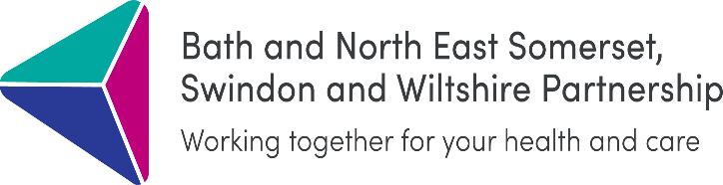

**Shaping a Healthier Future Engagement Summary Report**

**February 2022**

**1.** **Introduction**

In early 2020 the Bath and North East Somerset, Swindon and Wiltshire (BSW) Partnership published its health and care model and priorities for the delivery of health and care services across the region. In October 2021 BSW Partnership was able to return to those plans in the light of learnings from the pandemic and wanted to test with the local population whether the health and care model was still the right one or whether any changes need to be made.

An independent public engagement consultant, Martha Cox of Engagement Solutions, delivered a six-week public engagement project around the health and care model, working closely with health and local authority partners and focusing specifically on those facing health inequalities.

**2.** **Aims of engagement**

1. To raise awareness and inform local population about the BSW Partnership, why we need a health and care model and what it means for local people and communities.

2. To have a two-way dialogue with stakeholders about the key principles that underpin the health and care model to understand the barriers to access and the impact of these, particularly on those most affected by health inequalities.

3. To provide details to the public of how they can keep involved in the work going forward.

**3.** **Approach**

Public engagement on Shaping a Healthier Future ran from 2 November to 14 December 2021. A public survey and a series of webinars, workshops, interviews and presentations with health and care staff, people who use local health and care services and the voluntary, community and social enterprise (VCSE) sector.

These were publicised through social media, local networks, community newsletters, local media and presentations to key staff groups and other local organisations. Case studies were used to highlight examples of the new ways of working and a video was produced which explained the health and care model in detail.

**3.1** **Engagement with those experiencing health inequalities**

Leaflets and printed copies of the survey were widely distributed to GP practices (via the Primary Care Networks), community centres and housing associations to ensure that those who were digitally excluded also had an opportunity to participate and give their views. The surveys had a physical return address for people to respond.

Over 39 VCSE organisations who work with those experiencing health inequalities (excluding VCSE networks) supported workshops and/or interviews people with lived experience of health inequalities, or frontline staff working with those experiencing health inequalities.

**4.** **Results**

During the engagement period **1,441** people were engaged with at **65** events. In addition, **918** people completed the survey. **40** people were spoken to directly about their experiences of health inequalities. These included refugees and asylum seekers, people with learning disabilities and autism, members of the LGBTQ+ community, people with chronic long-term conditions, an unpaid carer and people recovering from alcohol and substance misuse.

**5. Outcomes from survey, workshop and interview results**

Survey respondents and workshop and interview participants were asked questions on a range of themes around the model of care including how this related to health inequalities and inclusion, finance, integration, access to GPs and other services, personalisation, workforce, specialist centres, and mental health.

Full respondents’ feedback is available in the full version of the Shaping a Healthier Future Engagement Report. The outcomes will influence proposed recommendations in the next revision of the health and care model including further development on:

* Digital inclusion and exclusion
* Mental health provision
* Workforce, recruitment, and access to services
* Finance models
* Vulnerable clients and their access to mainstream services
* Role of the voluntary, community and social enterprise sector
* Role of unpaid carers, volunteers, universities, schools, and public health

Overall, there was an adequate sample of people who were engaged with in a wide variety of ways to be able to say that, broadly speaking, people in BSW are in favour of the model. The significant sample size of people that were spoken to about their lived experience of health inequalities means that a number of the issues facing the most vulnerable in our society were highlighted and now can be addressed under the model. There were a number of concerns raised that need to be emphasised or clarified and most people requested further detail about how the model would work for their location or particular experience. There was general enthusiasm and willingness amongst local organisations to work collaboratively to effect this change and so the next phase will be to start genuine and meaningful co-production, building on some of the relationships generated during this engagement exercise.